Product Review and Rating Management System
Project Title: E-Commerce Order Management Database System

Project Title : E-Commerce Order Management Database System
Student Name : Asan Ahamed H
Register Number : C4S38006
Department : B.Sc Artificial Intelligence
Course : Artificial intelligence (AI)
Academic Year : 2024 – 2027

Product Review and Rating Management System
1. Create Review Table
CREATE TABLE Review (
ReviewID INT PRIMARY KEY,
ProductID INT,
CustomerName VARCHAR(50),
ReviewText VARCHAR(200),
ReviewDate DATE,
FOREIGN KEY (ProductID) REFERENCES Product(ProductID)
);
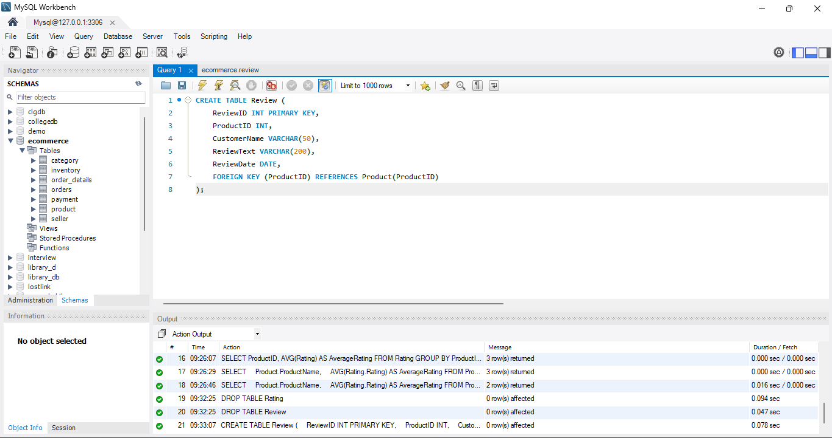

2. Create Rating Table
CREATE TABLE Rating (
RatingID INT PRIMARY KEY,
ProductID INT,
CustomerName VARCHAR(50),
Rating INT,
FOREIGN KEY (ProductID) REFERENCES Product(ProductID)
);

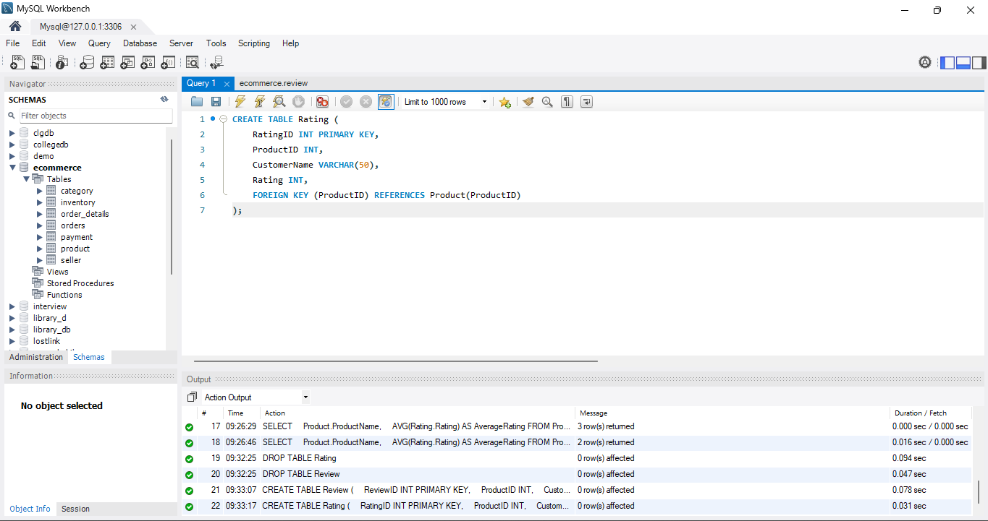

3. Insert Reviews
INSERT INTO Review VALUES
(1, 101, 'Arun', 'Good laptop', '2026-08-14'),
(2, 102, 'Kumar', 'Very good mobile', '2026-08-15'),
(3, 103, 'Ravi', 'Nice T-Shirt', '2026-08-16'),
(4, 101, 'Siva', 'Excellent laptop', '2026-08-17');

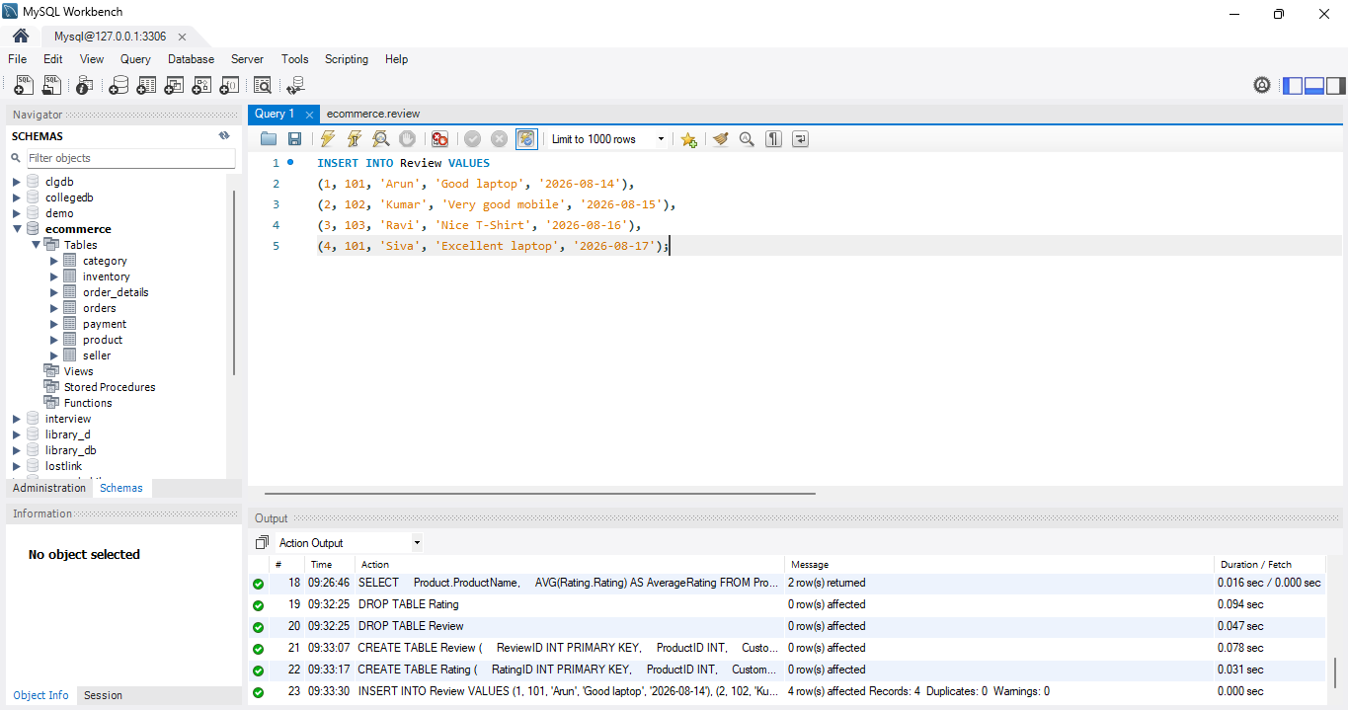

4. Insert Ratings
INSERT INTO Rating VALUES
(1, 101, 'Arun', 5),
(2, 102, 'Kumar', 4),
(3, 103, 'Ravi', 3),
(4, 101, 'Siva', 5);

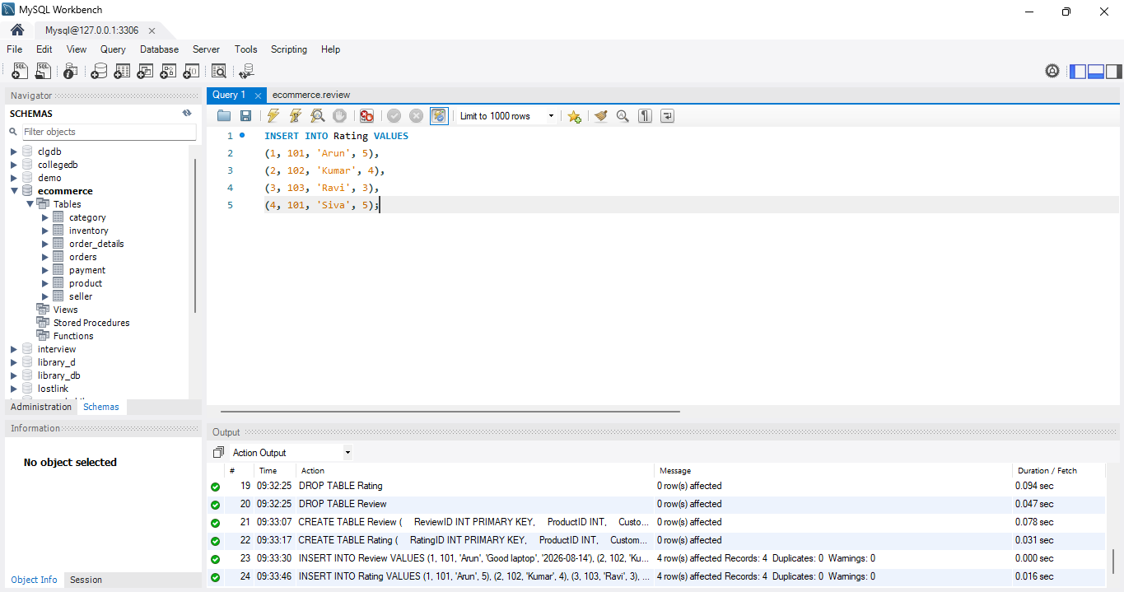

5. Display Product Reviews
SELECT * FROM Review;
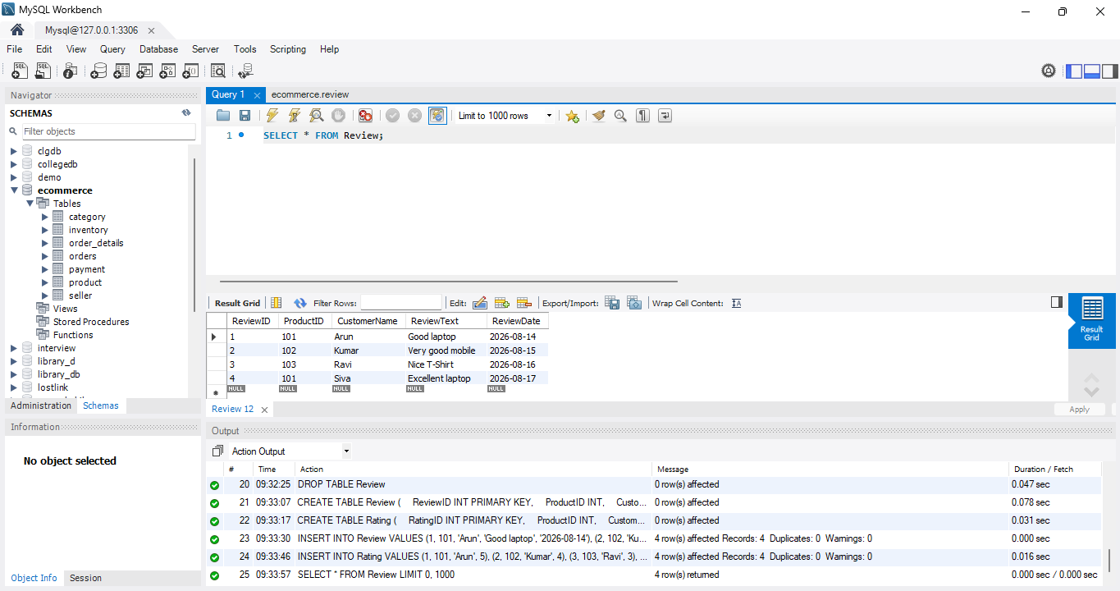

6. Display Reviews for a Particular Product
SELECT * FROM Review
WHERE ProductID = 101;
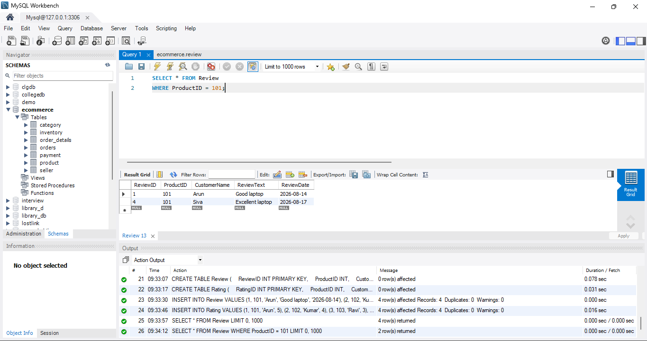

7. Calculate Average Rating
SELECT ProductID, AVG(Rating) AS AverageRating
FROM Rating
GROUP BY ProductID;
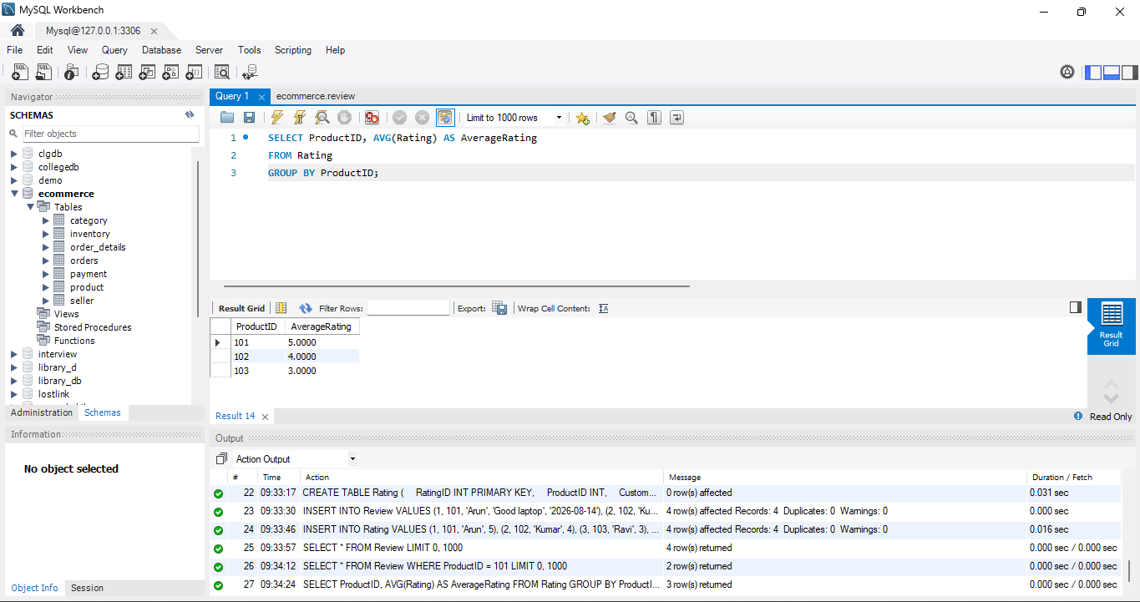

8. Show Product Name with Average Rating
SELECT
Product.ProductName,
AVG(Rating.Rating) AS AverageRating
FROM Product
JOIN Rating
ON Product.ProductID = Rating.ProductID
GROUP BY Product.ProductName;

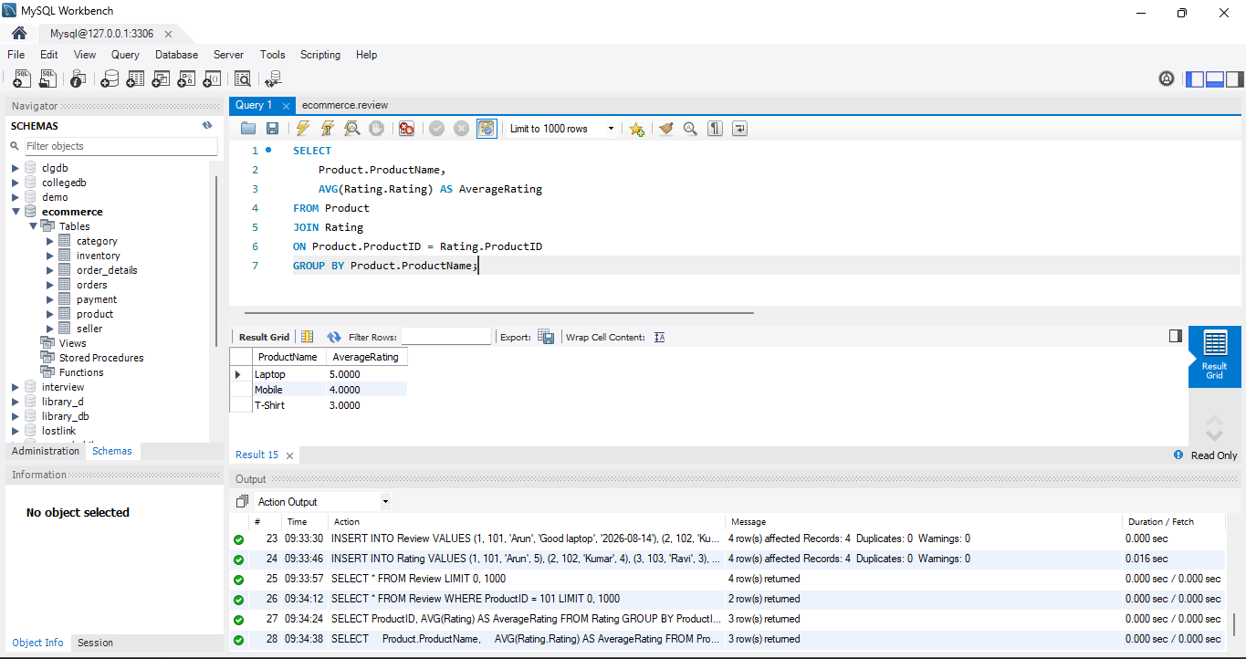

9. Identify Highly Rated Products
For products with an average rating of 4 or above:
SELECT
Product.ProductName,
AVG(Rating.Rating) AS AverageRating
FROM Product
JOIN Rating
ON Product.ProductID = Rating.ProductID
GROUP BY Product.ProductName
HAVING AVG(Rating.Rating) >= 4;

